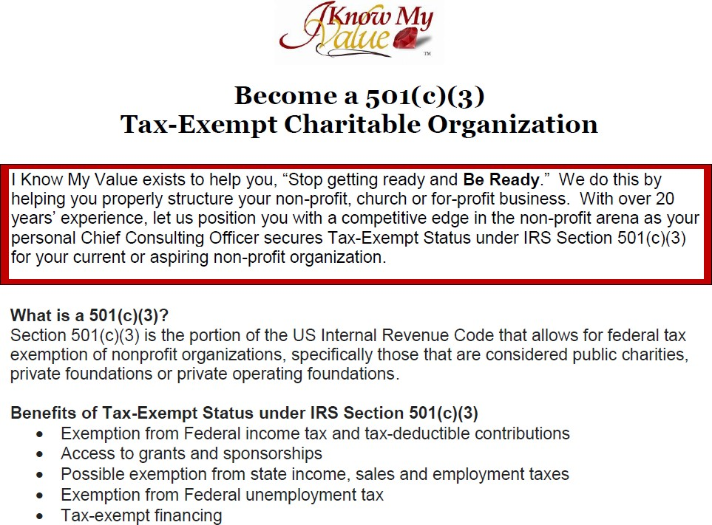

|  |  |  |  |
| --- | --- | --- | --- |
| **501(c)(3) PACKAGES**  **Choose your perfect INCORPORATION package** | **Standard (Launch)**  **$999**  **IRS federal filing fee INCLUDED**  (Excludes churches, schools, medical facilities  and foundations) | **Plus (Recommended)**  **$1,999**  **IRS federal filing fee INCLUDED** | **Elite**  **(Ready for Funding)**  **$2,999**  **IRS federal filing fee INCLUDED** |
| **Payment plans are available** | | | |
| **Creation of 501(c)(3) paperwork** | Included | Included | Included |
| **Completion of lengthy 501(c)(3)**  **application** | Included | Included | Included |
| **IRS Filing** | Included | Included | Included |
| **Nonprofit Corporate Binder** | Included | Included | Included |
| **Registered Agent** | 90 days | 1 year | 2 years |
| **Annual Report Assistance** | N/A | Included (1st year) | Included (1st year) |
| **Program Development** | 45 min consult | Develop 1-2 programs with defined descriptions. | Develop 3 programs plus...   * Detailed Descriptions * Grant narratives * Website and brochure content. |
| **Donation Letters** |  | 1 Included | 5 Included |
| **Elite (Ready for Funding) Benefits** | | | |
| **Sponsorship Package** |  |  | Included |
| **Grant Registration (Enter org in the grant database and complete**  **pre-steps)** |  |  | [1: Obtain a DUNS Number](https://www.grants.gov/web/grants/applicants/organization-registration/step-1-obtain-duns-number.html) [2: Register with SAM](https://www.grants.gov/web/grants/applicants/organization-registration/step-2-register-with-sam.html)  [3: Register with Grants.gov](https://www.grants.gov/web/grants/step-3-register-with-grantsgov.html) |
| **Business Credit Accelerator** |  |  | Provide a step-by-step plan for business credit. |
| **Business Capital Funding**  **Membership** |  |  | Membership and referrals to  Business Capital partners. |
| **Ongoing Support** |  |  | 1 year email support and 6-month prescheduled phone  support |

*Payment plans offered for Plus and Elite Plans. There is $150 OFF for full package payments verses payment plans.

*The 501(c)(3) filing fee is $600. Churches, schools, hospitals, foundations and certain organizations automatically excluded by the IRS for the 1023ez reduced filing fee.